python manage.py createsuperuser
then it will ask for the basic details give them
once super user created successfully
then start your server using python manage.py run server

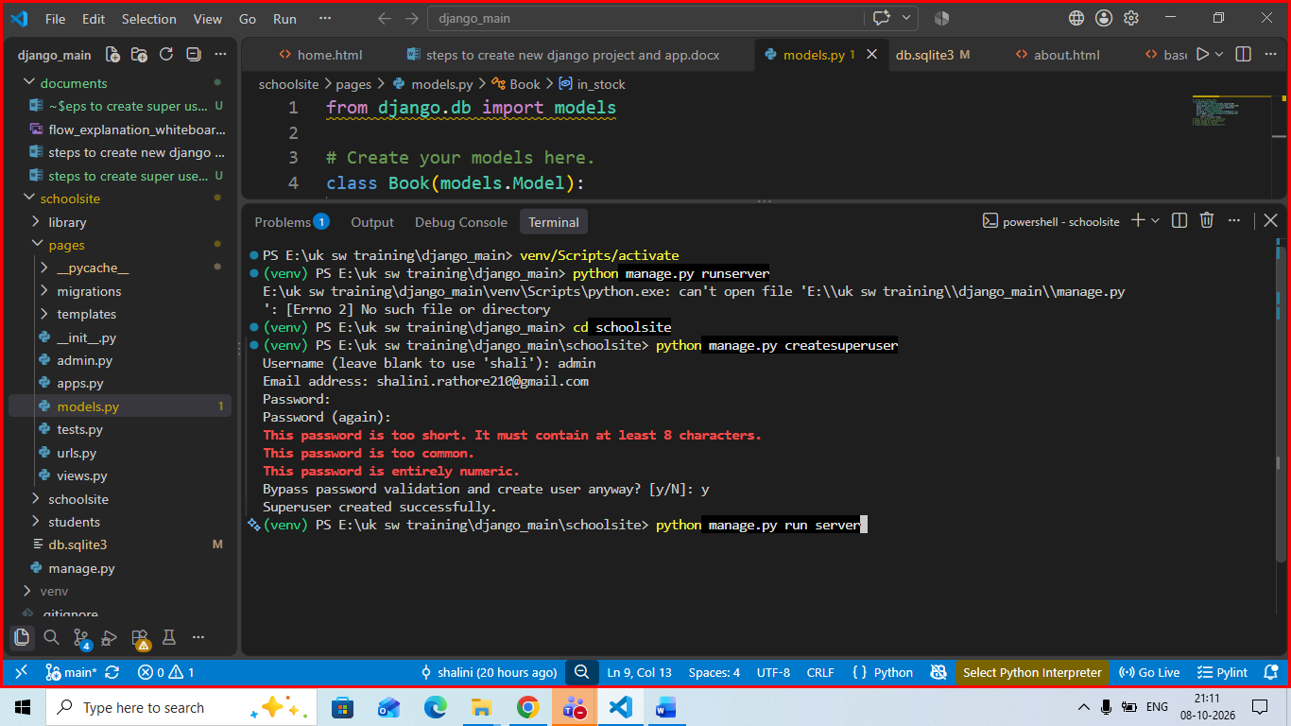
No space should be given between runserver
Go to the url
http://127.0.0.1:8000/admin
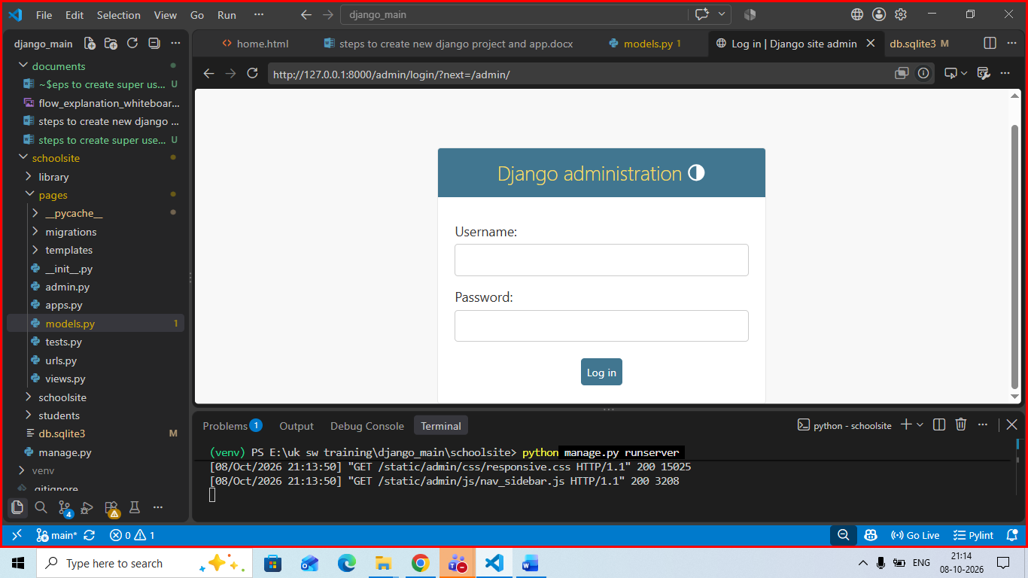
Provide your created username and pwd :
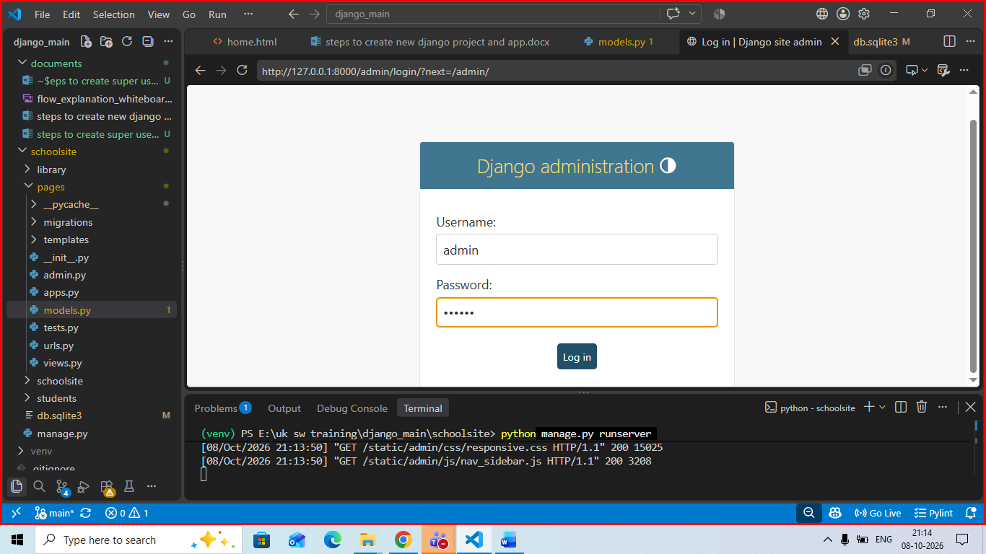 and click on login
Once that is done , go to the admin.py of the app in which you created a model
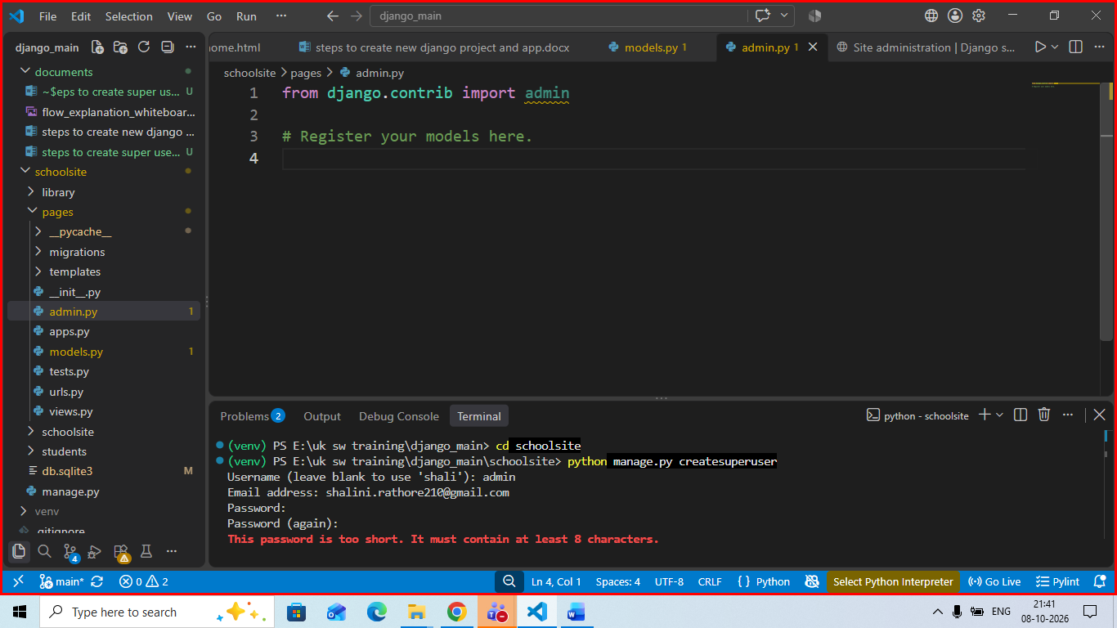
Then register your model here
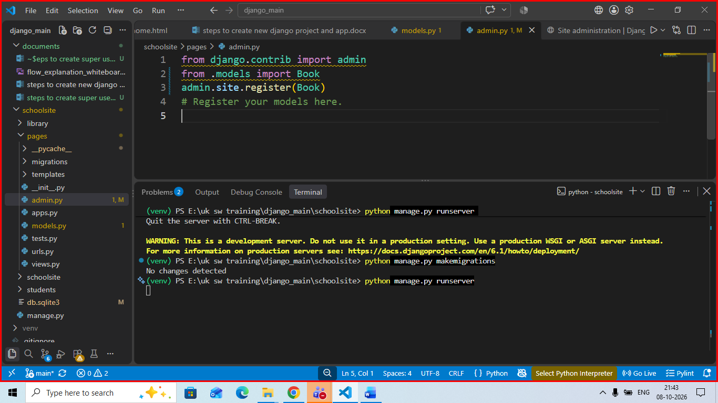
If there are any changes in the model execute the migration command and then run server
